**Raspberry PI Zero 2 W MSP430 (TI) Tiva C Series LaunchPad Microcontrollers Applications in a Satellite System**

**1. Introduction**

**Microcontroller Roles in Satellite Subsystems**

Modern satellite systems — especially CubeSats and small-scale platforms — require a mix of high processing power, ultra-low power efficiency, and real-time control. To meet these diverse demands, a hybrid architecture leveraging multiple microcontrollers is often deployed. This design ensures fault tolerance, modular development, and optimal resource allocation. In this context, **Raspberry Pi Zero 2 W**, **MSP430**, and **Tiva C Series LaunchPad** microcontrollers each serve specialized roles within the satellite subsystem:

**Raspberry Pi Zero 2 W – *Onboard Computer (OBC) & Payload Processing***

As a compact Linux-based single-board computer, the Raspberry Pi Zero 2 W handles **data-intensive tasks**, such as **image processing**, **machine learning**, and **high-level communication protocols**. Its quad-core 64-bit ARM Cortex-A53 processor makes it ideal for processing payload data from sensors like cameras or spectrometers. Although not real-time or radiation-hardened, it is well-suited for **non-critical tasks** that benefit from the flexibility and computing power of a general-purpose OS.

**MSP430 (Texas Instruments) – *Power Management Unit (PMU) & Sensor Interface***

The MSP430 microcontroller excels in **ultra-low power consumption**, making it the best choice for always-on operations such as **voltage/current monitoring**, **temperature sensing**, and **basic fault detection**. Operating efficiently even in deep-sleep modes, the MSP430 ensures **continuous environmental monitoring** while conserving energy—a crucial feature for long-duration missions with tight power budgets.

**Tiva C Series LaunchPad – *Attitude Determination & Control System (ADCS) & Real-Time Coordination***

The Tiva C Series, based on the ARM Cortex-M4F architecture, provides a robust platform for **real-time processing**, essential for **attitude control**, **reaction wheel management**, and **intra-satellite communication**. With support for FreeRTOS, floating-point math, and advanced interfaces like CAN and SPI, the Tiva C operates as the **deterministic control layer** of the satellite, orchestrating time-sensitive subsystems.

**RASPBERRY PI ZERO 2 W**

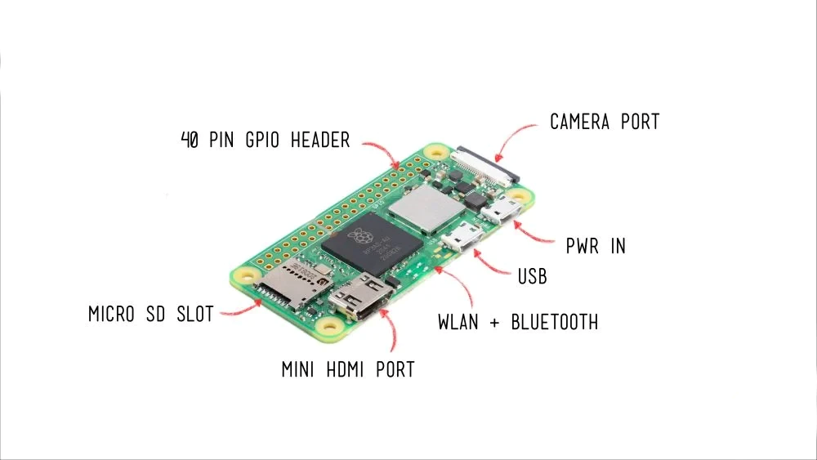

**Specifications:**

* 1GHz quad-core 64-bit Arm Cortex-A53 CPU
* 512MB SDRAM
* 2.4GHz 802.11 b/g/n wireless LAN
* Bluetooth 4.2, Bluetooth Low Energy (BLE), onboard antenna
* Mini HDMI port and micro–USB On-The-Go (OTG) port
* microSD card slot
* CSI-2 camera connector
* HAT-compatible 40-pin header footprint (unpopulated)
* H.264, MPEG-4 decode (1080p30); H.264 encode (1080p30)
* OpenGL ES 1.1, 2.0 graphics
* Micro USB power
* Composite video and reset pins via solder test points
* 65mm x 30mm

|  |  |  |
| --- | --- | --- |
| Feature | Specification | Satellite Role |
| CPU | 1GHz ARM1176 (Single-core) | Onboard Computer (OBC) |
| Memory | 512MB RAM | Payload Data Processing |
| Wireless | Wi-Fi 802.11n, Bluetooth 4.1 | Ground Debugging (proximity) |
| Power | 5V, ~350mA active | Non-critical (high-power tasks) |
| OS | Linux (Raspberry Pi OS) | Runs Python/C++ for imaging/AI |

**MSP430 (TI)**

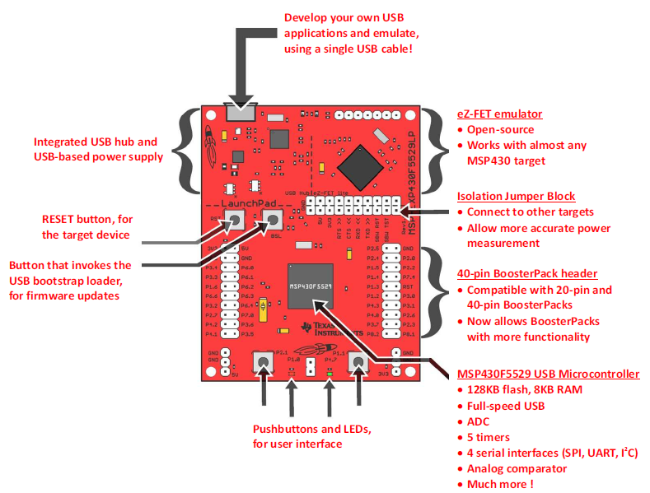

**Specifications:**

* **Architecture:** 16-bit RISC (Harvard architecture)
* **Core:** MSP430FRxx (FRAM variants available)
* **Clock Speed:** Up to 25 MHz
* **Memory:** 2 KB – 256 KB Flash/FRAM, 128 B – 32 KB RAM
* **Power Modes:** 5 ultra-low power modes (Sleep current < 0.1 µA)
* **Peripherals:** ADC, DAC, timers, UART, SPI, I2C, watchdog
* **Radiation Resistance:** Some variants offer radiation tolerance (e.g., MSP430FR5969)
* **Programming Languages:** C, Assembly
* **IDE/Tools:** Code Composer Studio (TI), Energia (Arduino-like), IAR Embedded Workbench
* **Strength:** Extremely low power, ideal for always-on monitoring
* **Weakness:** Limited processing power and RAM for complex tasks

|  |  |  |
| --- | --- | --- |
| Feature | Specification | Satellite Role |
| Architecture | 16-bit RISC (MSP430FRxx for FRAM) | Power Management Unit (PMU) |
| Power | 0.1µA (sleep), ~100µA/MHz (active) | Always-on sensor monitoring |
| Radiation | Some variants radiation-hardened | Reliable in harsh environments |
| Memory | 2KB–256KB Flash | Small RTOS or bare-metal code |

**Tiva C Series LaunchPad**

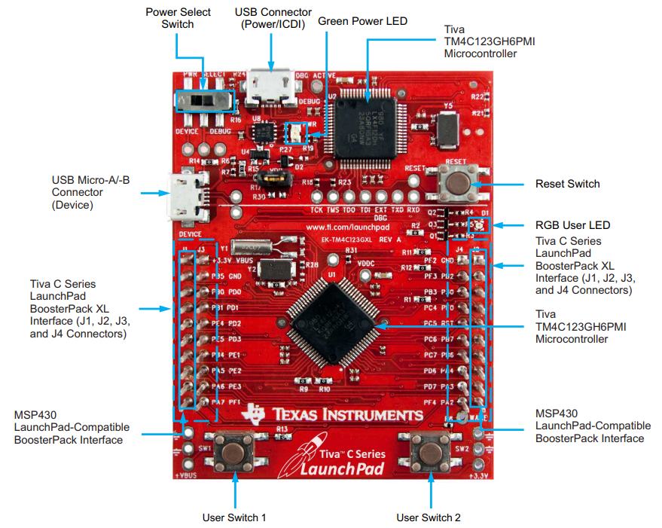

**Specifications:**

* **Architecture:** 32-bit ARM Cortex-M4F (Floating Point Unit + DSP)
* **Clock Speed:** Up to 80 MHz (TM4C123), 120 MHz (TM4C129)
* **Memory:** 256 KB – 1 MB Flash, 32 KB – 256 KB SRAM
* **Interfaces:** UART, SPI, I2C, USB, CAN, Ethernet, PWM, ADC
* **Real-Time Support:** FreeRTOS, TI-RTOS (deterministic multitasking)
* **Power Consumption:** ~1 mA/MHz (active)
* **Programming Languages:** C, C++
* **IDE/Tools:** Code Composer Studio (TI), Keil µVision, IAR Embedded Workbench
* **Strength:** Real-time control, advanced I/O, suitable for ADCS and inter-microcontroller coordination
* **Weakness:** Higher power consumption than MSP430, more complex to develop

|  |  |  |
| --- | --- | --- |
| Feature | Specification | Satellite Role |
| CPU | 80 – 120MHz Cortex-M4F (FPU/DSP) | Attitude Control (ADCs) |
| Memory | 256KB – 1MB Flash | Real-time control loops |
| Interfaces | CAN, Ethernet, USB | Inter-subsystem communication |
| Power | ~1mA/MHz | Balanced performance/power |

**2. Recommended Sensors & Communication Modules**

**2.1. Sensors**

|  |  |  |  |
| --- | --- | --- | --- |
| Sensor | Purpose | Best MCU | Interface |
| BME280 | Temp/pressure/humidity | MSP430 | I2C/SPI |
| MPU-6050 | Gyroscope/accelerometer (ADCS) | Tiva C | I2C |
| HMC5883L | Magnetometer (orientation) | Tiva C | I2C |
| Raspberry Pi Camera | Earth imaging | RPi Zero W | CSI-2 |
| INA219 | Power monitoring | MSP430 | I2C |

**2.2. Communication Modules**

|  |  |  |  |
| --- | --- | --- | --- |
| Module | Protocol | Best MCU | Use Case |
| RFM95W (LoRa) | LoRa | Tiva C | Long-range telemetry |
| AX.25 Modem | UHF/VHF | RPi Zero 2 W | Amateur radio downlink |
| CAN Bus (SN65HVD23) | CAN | Tiva C | Reliable intra-satellite comms |

**3. Programming and Integration**

A detailed breakdown of the **Raspberry Pi Zero 2 W**, **MSP430**, and **Tiva C Series LaunchPad** focusing on their *programming languages*, *architecture*, *IDEs/software*, and *efficiency* in satellite applications:

**3.1. Raspberry Pi Zero 2 W**

|  |  |
| --- | --- |
| Category | Details |
| Architecture | 64-bit Quad-Core ARM Cortex-A53 (1GHz) |
| OS | Raspberry Pi OS (Debian-based Linux) |
| Programming Languages | Python, C/C++, Bash, Rust, Go |
| IDEs & Tools | VS Code (via SSH or remote), Thonny, Geany, nano/vim |
| Software Support | OpenCV, TensorFlow Lite, GStreamer, ROS, WiringPi, pigpio, I2C-tools |
| Efficiency in Satellite Applications | |
| - Power Usage | ~0.6W–1.5W depending on load |
| - Real-time Capability | No true real-time OS; soft real-time only |
| - Best for | Payload processing, image compression, AI inference, ground debugging |
| - Limitations | Not radiation-hardened, sensitive to SEUs, requires robust power management and watchdogs |

**3.2. MSP430 (Texas Instruments)**

|  |  |
| --- | --- |
| Category | Details |
| Architecture | 16-bit RISC (Ultra-low-power, some FRAM variants) |
| Programming Languages | C, Assembly |
| IDEs & Tools | Code Composer Studio (CCS), IAR Embedded Workbench |
| Software Support | Energia (Arduino-like), MSP430 DriverLib, Grace GUI |
| Efficiency in Satellite Applications | |
| - Power Usage | Sleep: 0.1 µA, Active: ~100 µA/MHz |
| - Real-time Capability | Basic bare-metal or small RTOS |
| - Best for | Sensor polling, power management, watchdog supervision |
| - Radiation Suitability | Some variants more tolerant (FRAM > Flash), used in CubeSat PMUs |
| - Limitations | Limited computational power, small RAM/Flash, no FPU |

**3.3. Tiva C Series (ARM Cortex-M4)**

|  |  |
| --- | --- |
| Category | Details |
| Architecture | 32-bit ARM Cortex-M4F (with FPU and DSP) |
| Programming Languages | C, C++ |
| IDEs & Tools | Code Composer Studio (CCS), Keil µVision, IAR Embedded Workbench |
| Software Support | TI-RTOS, FreeRTOS, TivaWare, CMSIS |
| Efficiency in Satellite Applications | |
| - Power Usage | ~1–2 mA/MHz active, very efficient for Cortex-M |
| - Real-time Capability | Excellent – hardware deterministic with RTOS |
| - Best for | Real-time attitude control, reaction wheel control, CAN Bus |
| - Radiation Suitability | Not radiation-hardened, needs shielding or watchdogs |
| - Limitations | Requires tighter thermal and EMI controls in space environments |

**Features Summary Table**

|  |  |  |  |
| --- | --- | --- | --- |
| Feature | RPi Zero 2 W | MSP430 | Tiva C Series |
| CPU Arch | ARM Cortex-A53 | 16-bit RISC | ARM Cortex-M4F |
| OS | Linux (Debian) | None / Bare-metal | RTOS (TI-RTOS/FreeRTOS) |
| Main Languages | Python, C/C++, Bash | C, Assembly | C, C++ |
| IDE | VS Code, Thonny | Code Composer Studio | CCS, Keil, IAR |
| Real-time Operation | ✖ (soft only) | ✔ (bare-metal) | ✔✔ (RTOS with FPU) |
| Power Efficiency | Moderate (0.6–1.5W) | Excellent (µA range) | Very good (mA/MHz) |
| Best For | AI, Imaging, Downlink | Sensing, PMU, Sleep operations | ADCS, Control loops |
| Radiation Tolerance | Low | Medium (FRAM models) | Low–Medium (needs shielding) |
| Satellite Role | Payload Processing | Power & Sensor Monitor | ADCS & Intra-Sat Control |

**4. Advantages, Disadvantages & Recommended Alternatives**

**4.1. Raspberry Pi Zero W**

**Advantages:**

* High compute power and Linux ecosystem.
* Good for image processing, ML, and Python scripting.
* Built-in Wi-Fi/Bluetooth.

**Disadvantages:**

* Not real-time (no hardware-level timing guarantees).
* High power consumption (~300-400mA).
* Vulnerable to space radiation and temperature fluctuations.
* SD card corruption risk in high-vibration or radiation environments.

**Alternatives:**

|  |  |
| --- | --- |
| Alternative | Benefit |
| BeagleBone Black Industrial | Industrial-grade Linux SBC, better I/O protection, supports PRU real-time units. |
| Raspberry Pi Pico (RP2040) | Lower power, better for real-time tasks, but no Linux. |
| Teensy 4.1 | 600MHz, real-time capable with low-latency I/O. |
| STM32F7/H7 | Higher reliability, RTOS support, more rugged for control tasks. |
| Adafruit Feather M4 | ARM Cortex-M4, low power and modular sensor support. |
| Arduino Due | ARM Cortex-M3, better than Uno/Nano for real-time performance. |

**4.2. MSP430**

**Advantages:**

* Extremely low power consumption (ideal for always-on sensor nodes).
* Fast wake-up and sleep cycles.
* Some radiation-hardened versions exist.
* Stable analog performance.

**Disadvantages:**

* Very limited computing power and memory.
* Fewer peripheral options than modern MCUs.
* Smaller developer ecosystem compared to ARM-based chips.

**Alternatives:**

|  |  |
| --- | --- |
| Alternative | Benefit |
| Ambiq Apollo4 | Cortex-M4F ultra-low-power MCU with better performance. |
| STM32L4 | Low-power STM32 series with richer features than MSP430. |
| ATtiny85/84 | Compact, ultra-low-power 8-bit alternative for simple I/O tasks. |
| Arduino Nano Every | Affordable and low-power for basic tasks. |
| Adafruit Feather (M0) | Low-power Cortex-M0+ with great modular sensor support. |

**4.3. Tiva C Series**

**Advantages:**

* Cortex-M4F core supports DSP and floating-point ops.
* Real-time capability with multiple I/O protocols.
* Good balance between performance and power.
* Ideal for control systems and subsystem coordination.

**Disadvantages:**

* Less mainstream support compared to STM32 or ESP32.
* Slightly higher power draw than newer Cortex-M devices.
* Toolchain (Code Composer Studio) can be less flexible than open-source alternatives.

**Alternatives:**

|  |  |
| --- | --- |
| Alternative | Benefit |
| STM32F4/F7/H7 Series | Rich ecosystem, real-time ready, industry standard for embedded systems. |
| Teensy 4.0/4.1 | Excellent speed (600 MHz), compact form factor, great RT control. |
| Arduino Due | Cortex-M3 with plenty of I/O and better community support. |
| PIC32MX/PIC32MZ | Real-time capable and stable performance with legacy support. |
| BeagleBone Black | Good for hybrid real-time + Linux-based subsystems. |

**5. Prices and Shop Locations**

|  |
| --- |
| Raspberry PI Zero 2 W |
| <https://shop.ivyliam.com/product/raspberry-pi-zero-2-w/> |
| Ksh 3,800 |

|  |
| --- |
| MSP430 (TI) |
| <https://www.jumia.co.ke/generic-launchpad-development-board-ti-msp430-msp-exp430g2-277243100.html> |
| Ksh 3,805 |

|  |
| --- |
| Tiva C Series LaunchPad |
| <https://store.nerokas.co.ke/SKU-3330> |
| Ksh 3,200 |

**6. Microcontroller Suitability Summary**

|  |  |  |  |  |  |
| --- | --- | --- | --- | --- | --- |
| Microcontroller | Power Efficiency | Compute Performance | Radiation Resilience | Ecosystem/Support | Best Fit Role |
| MSP430 | ⭐⭐⭐⭐⭐ | ⭐⭐ | ⭐⭐⭐⭐ (FRx variants) | ⭐⭐⭐ | Sensor polling, PMU |
| Tiva C Series | ⭐⭐⭐ | ⭐⭐⭐⭐ | ⭐⭐ | ⭐⭐⭐ | ADCS, real-time control |
| RPi Zero W | ⭐ | ⭐⭐⭐⭐ | ⭐ | ⭐⭐⭐⭐ | Payload processing, imaging |
| STM32F4/F7/H7 | ⭐⭐⭐⭐ | ⭐⭐⭐⭐ | ⭐⭐ | ⭐⭐⭐⭐⭐ | General control, ADCS, telemetry |
| Teensy 4.1 | ⭐⭐ | ⭐⭐⭐⭐⭐ | ⭐⭐ | ⭐⭐⭐⭐ | High-speed data/control |
| Arduino Due | ⭐⭐ | ⭐⭐⭐ | ⭐⭐ | ⭐⭐⭐ | Mid-level control systems |
| Raspberry Pi Pico | ⭐⭐⭐⭐ | ⭐⭐ | ⭐⭐ | ⭐⭐⭐⭐ | Peripheral/sensor control |
| ESP32/ESP8266 | ⭐⭐ | ⭐⭐⭐ | ⭐ | ⭐⭐⭐⭐ | Ground link, testing/debug only |
| BeagleBone Black | ⭐⭐ | ⭐⭐⭐⭐ | ⭐⭐ | ⭐⭐⭐⭐ | Payload/processing |
| Adafruit Feather M4 | ⭐⭐⭐⭐ | ⭐⭐⭐ | ⭐⭐ | ⭐⭐⭐⭐ | Wireless sensing node |
| ATtiny Series | ⭐⭐⭐⭐⭐ | ⭐ | ⭐⭐ | ⭐⭐ | Redundant backup, switches |
| ATmega328/2560 | ⭐⭐⭐ | ⭐⭐ | ⭐⭐ | ⭐⭐⭐⭐ | Simple control/logic |
| PIC16F877A | ⭐⭐⭐ | ⭐⭐ | ⭐⭐ | ⭐⭐⭐ | Legacy tasks, I/O logic |